A SWR Simulator Hans ZS6KR

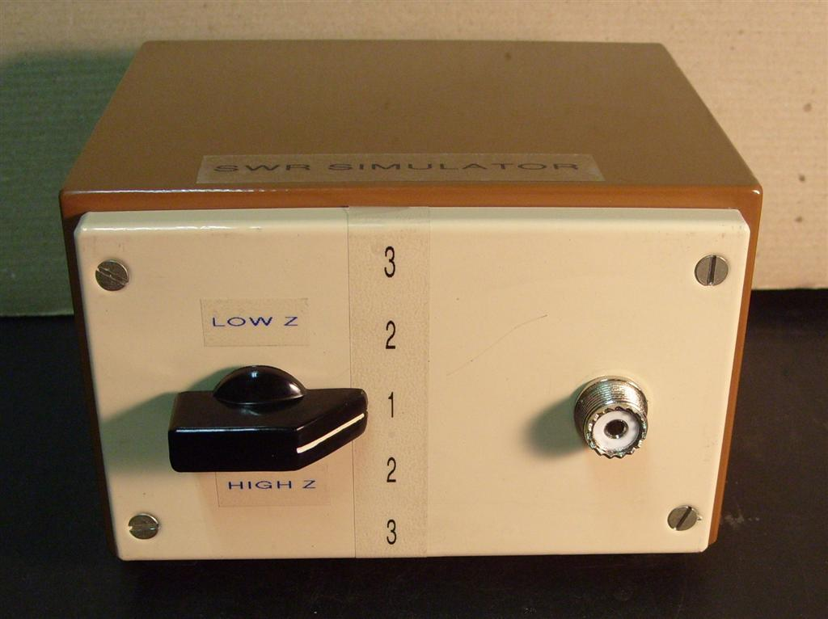
Rummaging amongst my small components I discovered some hybrid resistors that can be heat-sink mounted and are surprisingly small for their power handling.
Having three in hand marked 150W 50Ω (only 25x10mm!) I got fired up to design and make a variable RF dummy load for SWR=1, 2 and 3 which could be handy to check SWR indicators on radios and SWR meters as well as test radio and tuner behaviour when mismatched albeit of course only with a non-reactive load.

Drawing three blocks on paper with inputs and outputs it became obvious that it was an intricate switching exercise to connect
them sequentially in parallel and then sequentially in series to create 16.6Ω, 25Ω, 50Ω, 100Ω and 150Ω. That of course with the minimum of switches and at the same time have some sort of ergonomic arrangement of them. After much consideration I eventually stepped off the toggle switch idea and looked at how a two-wafer (4-pole 5-way) rotary switch could do it.
When having reduced my rubber considerably I could see a usable wiring scheme and that problem was out of the way. Since I wanted low and high Z it would necessitate two resistors to be insulated.

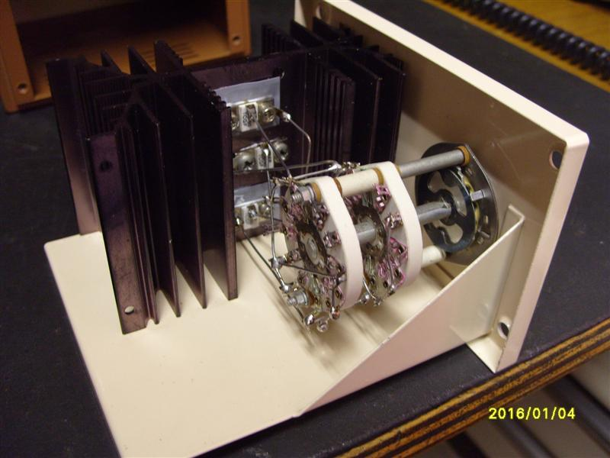
Mounting the resistors on a big enough heat- sink would enable 100W input if needed for a reasonable measurement period.
This I found in my heat-sink collection together with a suitable metal box which admittedly was a new one (in the box).
The switch emerged from my used switch box and was a suitable Centralab type with ceramic wafers.

As you can see, some tricks had to be used which cost a lot of time to make it all compatible.
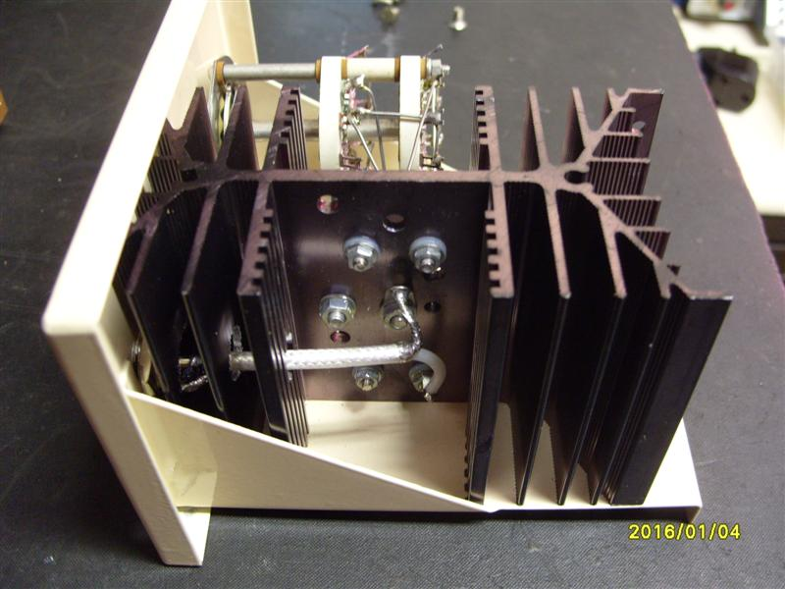
Since the switch only had a certain length,

some length had to be taken off the heatsink towards the front panel sothat wiring to the resistors could be more direct.
Also since there was no space for an input socket, the heatsink fins were drilled right through for the input coax.

Measuring return loss with a spectrum analyzer and relectometer showed some awful resonances due to wiring lengths and the insulated resistors - heatsink capacitances. It is however perfect up to 30MHz so the effort was not for nothing.
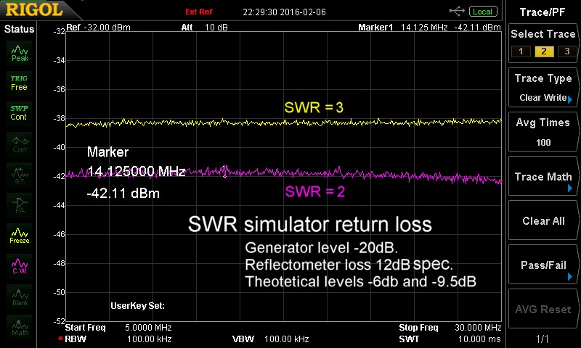
In retrospect my advice to anyone wishing to make something similar with much higher frequency capability it will be better to only make a parallel configuration (16.6Ω, 25Ω, 50Ω) sothat each resistor
can be mounted direct to a heatsink and a common ground.
Two toggle switches close by can do the SWR choice. For SWR=1 and 3 a single switch will suffice.

